NATIONAL UNIVERSITY OF MODERN LANGUAGE ISLAMABAD
Lab 12


Submitted to:
Sir Hassan Shah
Submitted by:
Zulqarnain Hassan
Roll No: …………………… SP21379
Subject: …………………… computer network
Department: ……………… BSSE-5-Afternoon
Date: ……………………… 13-12-2024

Objectives
- Configure the hostname of a router.
- Configure the password for a router.
- We will configure three Cisco routers.
- We will enable these routers for dynamic routing using the RIP protocol

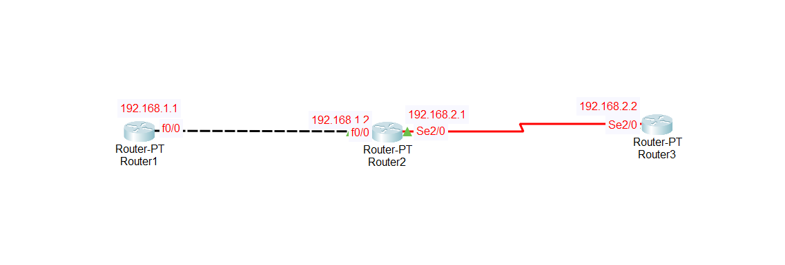

Lab tasks

Task1:
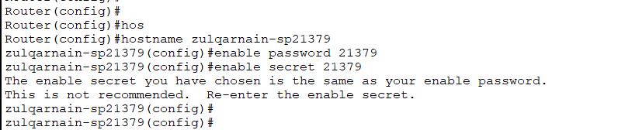
Task2:
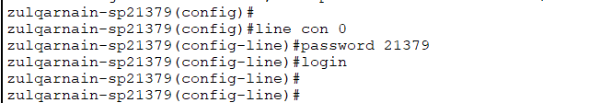
Task3:
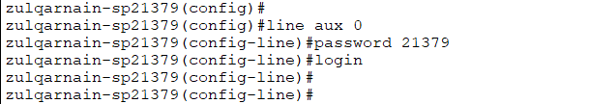

Task4: host name.
Router1:
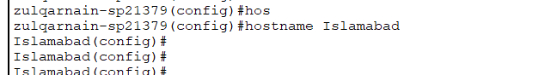

Router2:

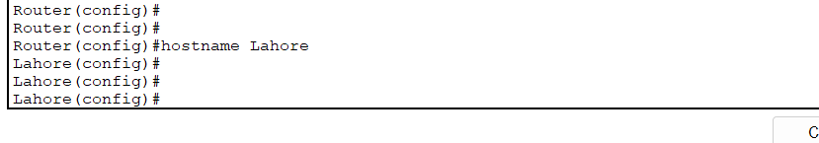
Router3:

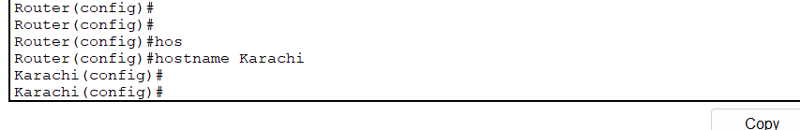

Task 5: IP address to router interfaces
Router1:
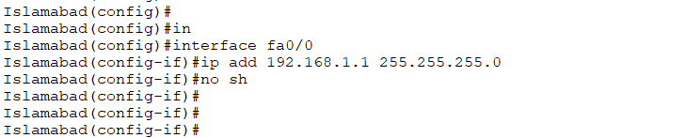

Router2:

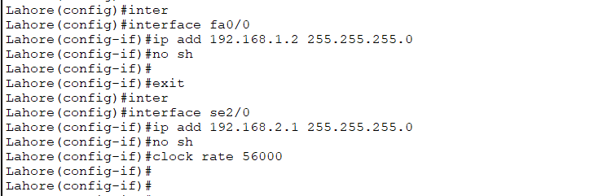

Router3:


Task 6:
Router1:
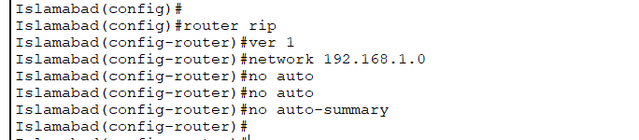

Router2:

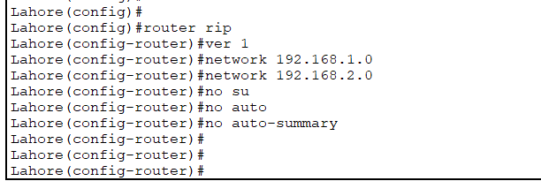

Router3:

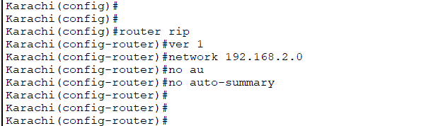

Task 7:

Router1:
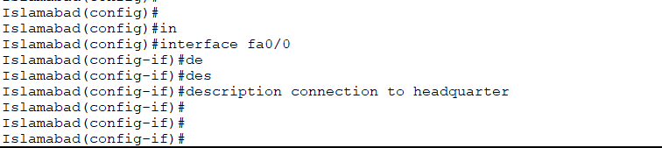

Router2:

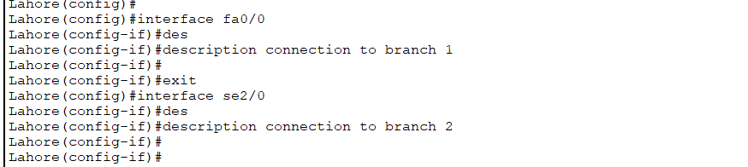

Router3:

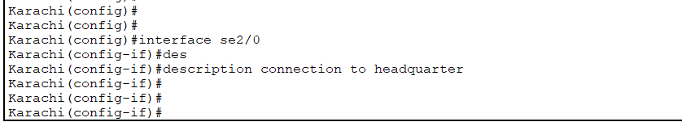

Task 8: On all routers set MOTD

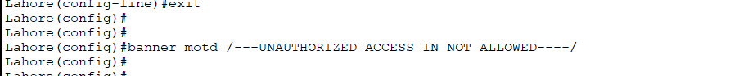

Change the rip version to 2:
Router1:
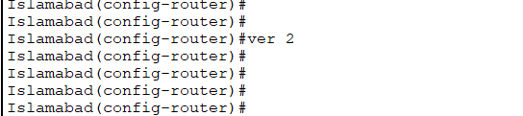
Router2:

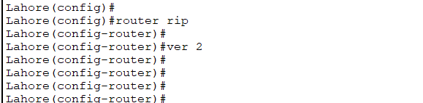

Router3:
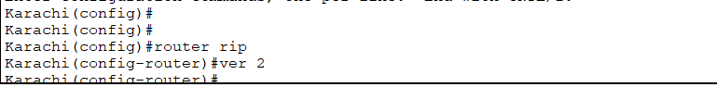

Use debug command to get the details:
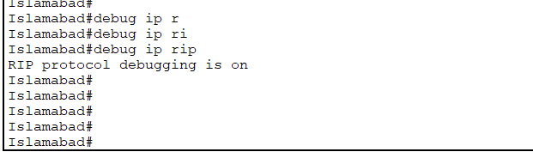

show ip route

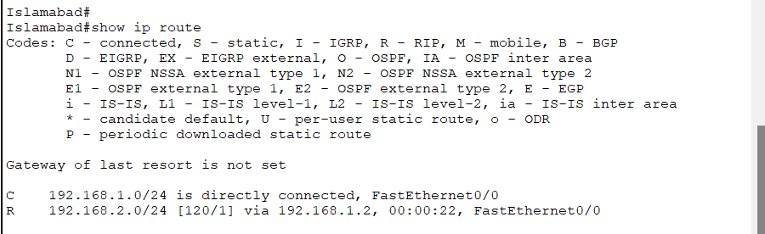

show ip protocols:
